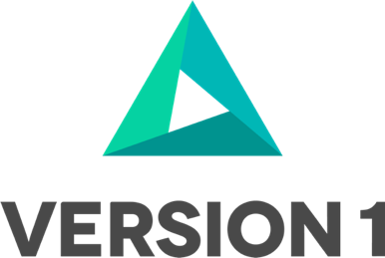

DM3-020 FIN AP Transactions Data Reconciliation

Maximise Toolkit

Prepared by: <Author>|<Date>

@Copyright 2021 Version 1 – All Rights Reserved

**Table of Contents**

1. Introduction 1

1.1 Purpose 1

2. Unit Testing 2

3. Unit Testing Extraction and Transformation of AP Transactions Data 3

3.1 Stage Gate Data Verification Process 3

3.1.1 Stage Gate 1 3

3.1.2 Stage Gate 2 3

3.1.3 Stage Gate 3 3

4. AP Transactions data reconciliation 4

4.1 Record Count Check 4

4.2 User Interface Sampling 5

4.3 Detailed Data Reconciliation 7

5. Reference Documents 14

6. Open and Closed Issues 15

**Version Control**

|  |  |  |  |
| --- | --- | --- | --- |
| **Date** | **Version** | **Changed By** | **Reason for Change** |
| First Draft | 0.1 | Author | Initial draft |
|  |  |  |  |

**Circulation List**

|  |  |
| --- | --- |
| **Name** | **Organisation/Title** |
|  |  |
|  |  |

**Reference Documents**

|  |  |  |
| --- | --- | --- |
| **Title** | **Description** | **Owner** |
|  |  |  |
|  |  |  |

# Introduction

This document describes how the audit and reconciliation of the Accounts Payables (AP) Transactions component data will be performed. It outlines how the data will be presented to the Business, who will then check that the data is correct against the data within the source E-Business Suite system which is the source of the data.

The AP Invoices data extract provided from the source system will be transformed and the FBDI files generated based on source data using the ‘Maximise: Data Migration Process’. When the FBDI files are loaded into ERP Cloud, it will be reported on using the standard reports.

The Supplier Invoices will be loaded against a ‘data migration’ account, this account can then be reconciled to the AP open balances and confirm that the balance is zero. The Finance workstream should confirm that the AP subledger is reconciled with GL in the source E-Business Suite system prior to the migration to ensure that the balances are equal.

Standard Oracle E-Business Suite reports recommended for use in the reconciliation process are:

• Accounts Payables Trial Balance

• Third Party Account Balances Report (Supplier)

• AP Aging reports

These reports will be used to compared against the AP Transaction information in the source E-Business Suite system. Any differences or discrepancies found will be investigated and resolved in the target ERP Cloud system.

## 1.1 Purpose

The Maximise - CV.065 FIN AP Transaction data Reconciliation document is used as follows:

1. Describe the process for business audit and reconciliation of the AP Supplier Invoices created in Oracle Cloud.
2. Describe how the AP Invoices data to be reconciled will be extracted from Oracle Cloud into Excel and how the error details should be presented to the Migration team on completion of Business Reconciliation.
3. To record any issues found at a technical level, ensuring that all the data within source, data migration and transform are accounted for and at a functional level, ensuring that all key business metrics remain unchanged pre, and post-migration and how these will be corrected well in advance of system Go-Live.

# Unit Testing

The approach taken to unit testing the Extract, Transform and Load (ETL) routines is as follows:

1. The Unit Testing process seeks to identify coding/mapping defects and verify the data loaded.
2. The test case(s) will test every path through the code and mapping and will also include error conditions to be certain that the individual components are working correctly.
3. The tests are carried out within a development environment and makes no pretence of being a fully comprehensive check.

Any defects identified are resolved as soon as they are detected.

The attached ‘Maximise - TE.020 FIN AP Transactions Draft file covers, Test cases, Test Types, Test Actions, Test Data, Expected Results and Actual Results.



# Unit Testing Extraction and Transformation of AP Transactions Data

1. Maximise Extract Procedures (_STG) extract raw customer data to populate relevant extract staging tables e.g. XXMX_??????_STG). No data transformation or enrichment is performed during this stage.
2. OIC Transformation flows / PLSQL Transformation Procedures (_XFM) read the raw data from the STG table and copy it to the relevant Transformed Data table (e.g. XXMX_??????_XFM). The data is not transformed during the move. This happens as a series of updates on the XFM table after it has been populated with the raw data from the STG table.
3. Once the data has been transformed/enriched, an OIC/PLSQL file generation flow will extract the data from the XFM table and generate one or more data files to be transmitted to Oracle Fusion Cloud.
4. These data files are encapsulated within one or more zip files along with an appropriate properties file (the properties file enables Fusion Cloud to identify the appropriate import job to execute to load and import the data). The properties file also includes all parameters required by the import job.
5. The properties file loads data into Universal Content Management (UCM) directories specific to the business object. It also takes contents of the zip/csv file and loads the respective interface tables.
6. Finally, the import job (ERP cloud scheduled) process is triggered that imports data from the interface tables into the ERP Cloud base tables for the data object. On completion the import job produces log files that are used to analyse the execution of the import e.g., successful imports, failures etc.

## Stage Gate Data Verification Process

There are three ‘Stage Gates’ for migration which are to be signed off by the workstream lead prior to progressing to the next phase of development/ load.

## Stage Gate 1

This step verifies that the data extracted from source matches the criteria set out in the CV40 document. In this case it will involve checking the extraction criteria is returning the expected record count by an independent check of data using an existing SQL report provided by the DM team. The location that this check should be performed in is the staging table.

## Stage Gate 2

This step verifies that data has been transformed in line with the CV40 specifications and that there have been no unexpected drops or increases in row counts. This step is the final step before load into the fusion application.

## Stage Gate 3

This step reconciles what was loaded by Version 1 data migration team, ensuring that all rows which were provided have loaded, and that any data loaded is complete and accurate as supplied by the load file from Stage Gate 2.

|  |  |  |  |
| --- | --- | --- | --- |
| **Data Object** | **EBS Report** | **ERP Cloud Report** | **Comments** |
| All | Accounts Payables Trial Balance | Payables Trial Balance Report |  |
| All | Third Party Balances Report | Third Party Account Balance Report |  |
| All |  | Payables Aging Report |  |

# AP Transactions data reconciliation

AP Transactions data reconciliation and accepting migrated data lies with the business owner. We recommended this is a time managed activity and business owner and any other client resources needed to help complete the actions must plan the required time in consultation with the Version 1 Project Manager and implementation team.

Based on our experience in implementing Oracle ERP Cloud projects we recommend as a minimum a three-stage reconciliation process for data validation. The guiding principles in the three-stage reconciliation process are common across most business data objects migrated from legacy to Oracle Cloud applications. However, the level of analysis carried out for each of the data objects will vary based on the type and characteristics of the data.

The recommended reconciliation process comprises of the three stages outlined below:

1. **Record Count Check**
2. **User Interface Sampling**
3. **Detailed Data Reconciliation**

## Record Count Check

Purpose: The purpose of this stage is to compare record count loaded into Oracle ERP Cloud with the EBS record in EBS. In cases where the record count in Oracle Cloud is lower or higher than EBS defects must be logged to enable actions plans to be agreed in readiness for Go-live.

Note: This stage is a quick ‘sense check’ on the number of records and requires limited/low effort.

Actions: The actions required to complete this stage are outlined below. The actions must be carried out for each of the AP Transaction types (classes) e.g., for Invoices, Credit Memos and so on.

1. Identify the data object that is to be reconciled e.g., Standard Invoices (count).
2. Get record count for the data object from the EBS Report.
3. Get record count for the data object from the ERP Cloud Report.
4. Compare the two numbers in 2) and 3) above.
5. In cases where count is not matching, note the difference. The difference will require further investigation in Stage 3 – ‘3. Detailed Data Reconciliation’.

Example:

|  |  |
| --- | --- |
| **Action** | **Output** |
| 1. Identify the data object that is to be reconciled | Invoices |
| 1. Get record count for the data object from the EBS Report. | EBS Report Invoice Count = 158 |
| 1. Get record count for the data object from the ERP Cloud Report. | ERP Cloud Report Invoice Count = 158 |
| 1. Compare the two numbers in 2) and 3) above. | Difference = 158 - 158  = 0  EBS has same number of records as ERP Cloud |
| 1. In cases where count is not matching, note the difference. The difference will require further investigation in Stage | Not required. Records match |

## User Interface Sampling

Purpose: The purpose of this stage is to check a small number of records using the user interfaces in ERP Cloud and in EBS. Looking at the records from the front end will give users the confidence that data migrated is of high quality and that the data has been migrated to the correct fields in the user interface. In case of discrepancies defects must be logged to enable actions plans to be agreed in readiness for Go-live.

Note: This is no specific recommendation on the number of records that should be sample checked. Business owners should decide how many records shall be sample checked based on factors such as – resources and time to be allocated to this task, number of records migrated, number of top/business critical customer transactions and so on.

Actions: The actions required to complete this stage are outlined below. The actions must be carried out for each of the AP Transactions types i.e. Invoice, Credit Memo etc.

1. Identify the AP Transaction to be sample checked e.g., Standard Invoice 3445743.
2. Query the AP Invoice record in EBS user interface.
3. Query the AP Invoice record in ERP Cloud user interface.
4. Compare the AP Invoice record in the two user interfaces.
5. In case of any discrepancies/differences found log defects for investigation and resolution.
6. Repeat the above steps for all AP Transaction Types to be sample checked.

Example:

|  |  |
| --- | --- |
| **EBS** | **ERP Cloud** |
| Standard Invoice: | **Standard Invoice:** |
| Credit Memo: | **Credit Memo:** |

## Detailed Data Reconciliation

Purpose: The purpose of this stage is to check the invoice amounts and accounting balances to ensure that the invoices migration is accurate. In case of discrepancies defects must be logged to enable actions plans to be agreed in readiness for Go-live.

Actions: There are three key actions required to complete this stage are outlined below.

1. Compare Sub-ledger balances:
2. Use Third Party Balances Report compare AP Transactions
3. Use AP Aging Reports
4. **Compare Sub-ledger balances:**

The sub-ledger control accounts for the transactions loaded to Payables should agree with the GL control accounts that were migrated from E-Business Suite GL to ERP Cloud GL.

The process to reverse the ERP Cloud AP Transaction balances transferred to GL to avoid double accounting must be completed.

You can use Payables Trial Balance Report to Lists and subtotals by supplier and liability account, all unpaid and partially paid invoices that Payables transferred to the general ledger.

* Log in to Oracle E-Business suite
* Navigate to the AP Super User Global responsibility
* Select Other : Requests > Run
* Select Single Request and click Ok
* Search for Accounts Payable Trial Balance and enter the parameters for the report definition and enter journal source as Payables
* Click Ok and then Submit the report

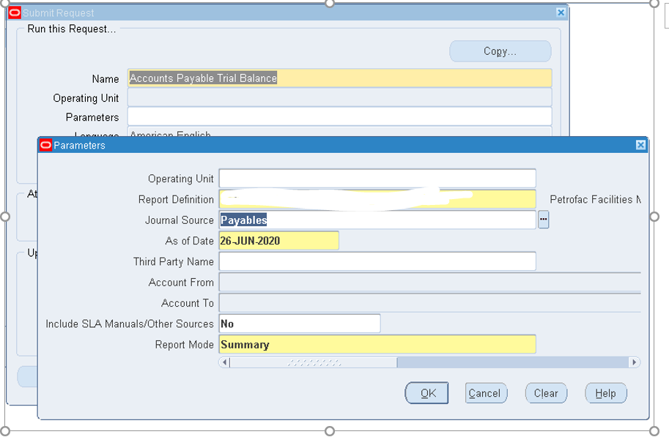

How to run the Payables Trial Balance Report ERP Cloud:

* Log in to Oracle ERP Cloud
* Navigate to Payables > Invoices
* From the reports icon on the right select Payables Trial Balance Report

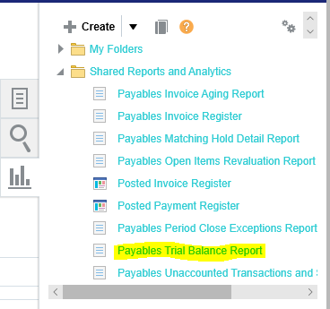

* Click Schedule
* Select the Ledger and Business Unit and click Submit
* The output will look similar to the sample below and a full sample report can be viewed at [Payables Trial Balance Report](http://www.oracle.com/webfolder/technetwork/docs/reports/r13/sample-reports/financials/AP/Payables%20Trial%20Balance%20Report.pdf)

Example screenshot of the Payables Trial Balance report:

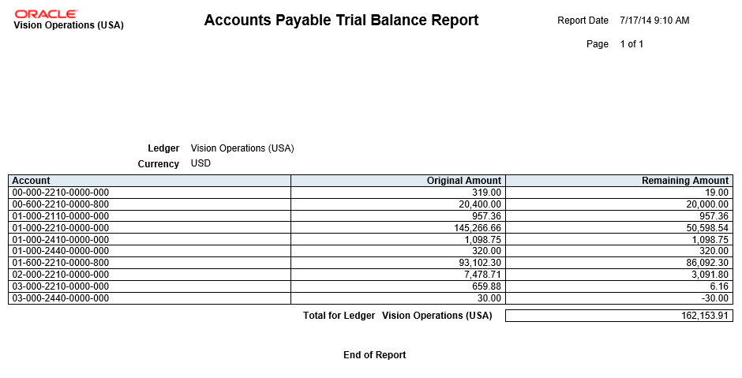

1. **Use Third Party Balances Report to compare AP Transactions**

Displays information for each account of the third party and third-party site, and account identification. This report is a tool for auditing third-party accounts. The same report can be run the EBS and in ERP Cloud and the AP Transactions compared.

How to run the Transaction Detail Report in E-Business Suite:

* Logon to Oracle E-Business suite
* Navigate to a Receivables responsibility (e.g. AP Super User Global responsibility)
* Run Concurrent Requests/Reports - Search for Third Party Balances Report and enter the parameters for the Ledger you are running it for along with the period
* Run the **Third Party Balances Report**, specifying the **Journal Entry Source** as *Payables* and the **Third-Party Type** as *Supplier*.
* Enter the account range (screenshot is an example only) and click Ok
* Submit the request

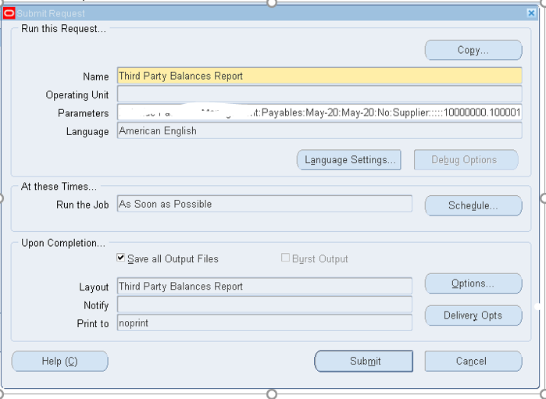

How to run the Third Party Balances ERP Cloud:

* Logon to Oracle ERP Cloud
* Navigate to Tools > Scheduled Processes (need General Accounting Manager or Payables Manager roles)

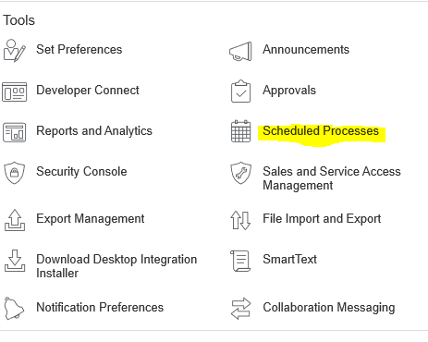

* Click schedule new process
* Enter Third-Party Account Balance Report and click OK

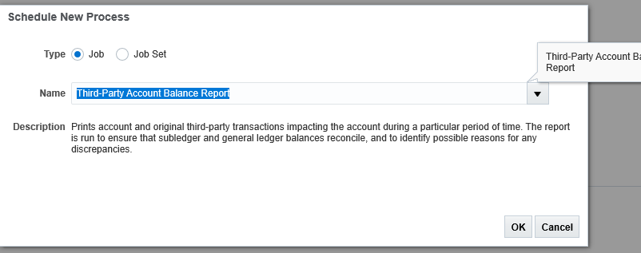

* Enter application as Payables, select the ledger, legal entity, period from/to, journal entry source is payables and third-party type is supplier
* Click Submit

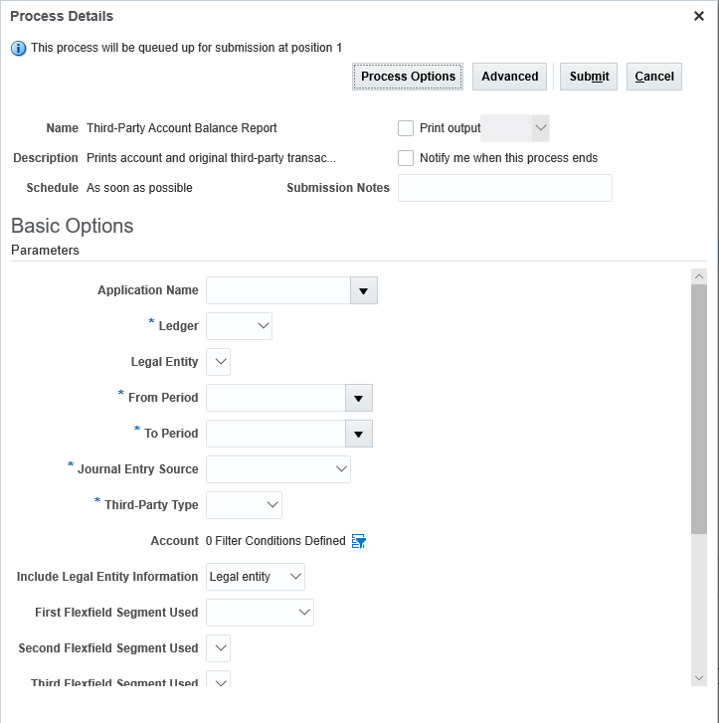

* The output will look similar to the sample below and a full sample report can be viewed at [Third-Party Account Balances Report](http://www.oracle.com/webfolder/technetwork/docs/reports/r13/sample-reports/financials/JE/Third%20Party%20Account%20Balance%20Report.pdf)

Example screenshot of the Third-Party Balance report:

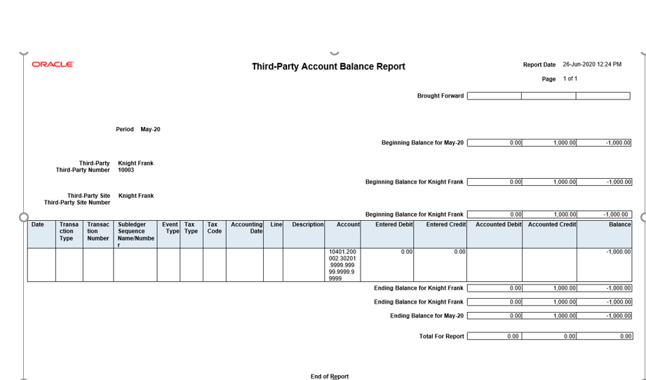

1. **Use AP Aging Reports**

Payables Aging by General Ledger Account Report - Lists unpaid invoices according to the specified aging periods. The report provides the break-down of the accounts payable balance across aging buckets that you can configure. Before running this report, create aging periods on the Create Aging Periods page and run the Apply Missing Conversion Rates process to provide missing conversion rate information.

* Schedule and run this report from the Scheduled Processes work area on the Navigator menu.
* Run the report to review the outstanding amounts due to a supplier, and for how long the invoice instalments have been due.
* You can run this report for a business unit, supplier, invoice type, and aging period. You also have various sorting options and can specify whether to include invoice and supplier site details.

# Reference Documents

Listing of reference documents related to AP Transaction data migration.

|  |  |  |
| --- | --- | --- |
| **#** | **Document Name** | **Description** |
| 1 |  |  |
| 2 |  |  |
| 3 |  |  |
| 4 |  |  |
| 5 |  |  |

# Open and Closed Issues

Listing of open and closed issues.

|  |  |  |  |  |  |
| --- | --- | --- | --- | --- | --- |
| **ID** | **Issue** | **Status** | **Resolution** | **Responsibility** | **Target Resolution Date** |
| 1 |  |  |  |  |  |
| 2 |  |  |  |  |  |
| 3 |  |  |  |  |  |
| 4 |  |  |  |  |  |
| 5 |  |  |  |  |  |

**Glossary**

|  |  |
| --- | --- |
| Term | Description / Meaning |
| AP | Account Payable |
| ATP | Autonomous Transaction Process |
| BIP | Business Intelligence Publisher |
| BPA | Blanket Purchase Agreement |
| Cloud ERP | Oracle Enterprise Resource Planning Cloud |
| BU | Business Unit(s) |
| CPA | Contract Purchase Agreement |
| CSV | Comma Separated Value |
| DBCS | Database Cloud Service |
| DQ | Data Quality |
| EBS | E-Business Suite |
| EDQ | Enterprise Data Quality |
| FA | Fixed Assets |
| FBDI | File Based Data Import |
| Fusion ERP | Oracle Enterprise Resource Planning Fusion Applications |
| HCM | Human Capital Management |
| HR | Human Resource |
| IC | Inter-Company |
| OC | Oracle Consulting (Team from Version 1) |
| PB2 | Playback 2 |
| PO | Purchase Order |
| R12 | Oracle e Business Suite R12 |
| SCM | Supply Chain Management |
| SQL | Structured Query Language |
| UCM | Universal Content Management |



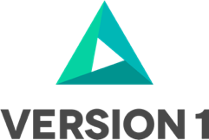

[**www.version1.com**](http://www.version1.com)

*`*